1. **Define the terms: Website, Webpage, Web browser, Web server, HTML, CSS?**

* Website: collection of files we can refer with the help of website URL
* Webpages:  A document written in HTML that you can see online, using a web browser
* Web browser: where we can search any website of any things that we want is called Web Browser.
* Web server: A web server is software and hardware that uses HTTP/HTTPS and other protocols to respond to client requests made over the World Wide Web.
* HTML: Hyper Text Mark-up Language. Use to create structure of web-pages.
* CSS: Cascading style sheets. Use to give style to the html structure/web-pages.

1. **Create a webpage to show “This is my first HTML page”?**
   * <h1>This is my first HTML page</h1>

1. **Display top 10 IT companies list in html webpage?**

<ol>

        <li>MicroSoft</li>

      <li>Tos </li>

        <li>Infosys</li>

        <li>HCL Technologies</li>

        <li>Wipro Limited</li>

        <li>LTIMindtree Ltd.</li>

        <li>Tech Mahindra Ltd.</li>

        <li>MphasiS Ltd.</li>

        <li>Persistent</li>

        <li>Oracle Fin Serv</li>

</ol>

1. **Create a dropdown list?**

 <label for="Hobbies" id="Hobbie">Choose Hobbie:</label>

    <select id="Hobbies">

        <option value="select" selected disabled>Select Hobbie</option>

        <option value="playing">playing</option>

        <option value="Reading">Reading</option>

        <option value="Dancing">Dancing</option>

        <option value="music">music</option>

    </select>

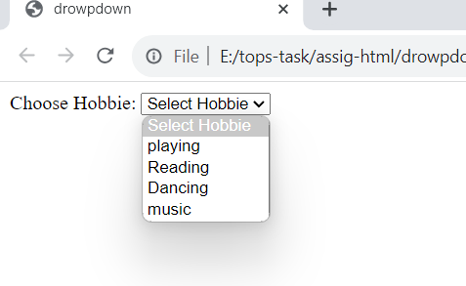

1. **Create a Table Of college Management system using row span & col span?**

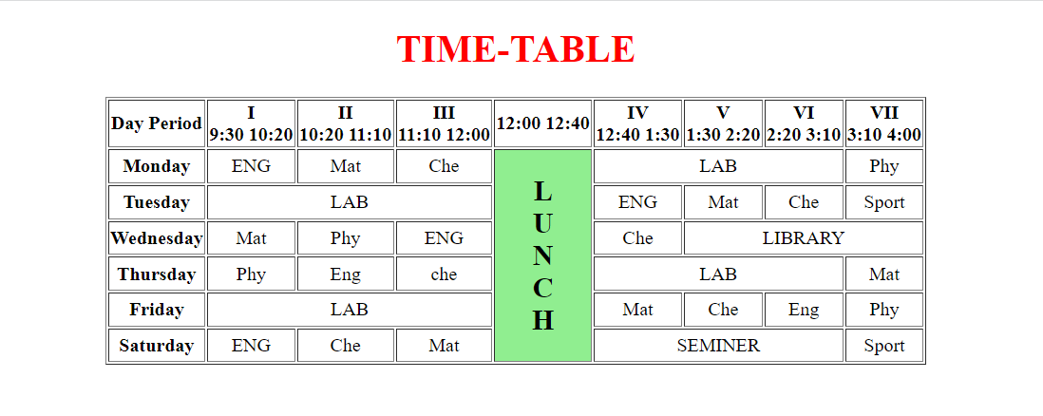

1. **Create below table using HTML table tags?**

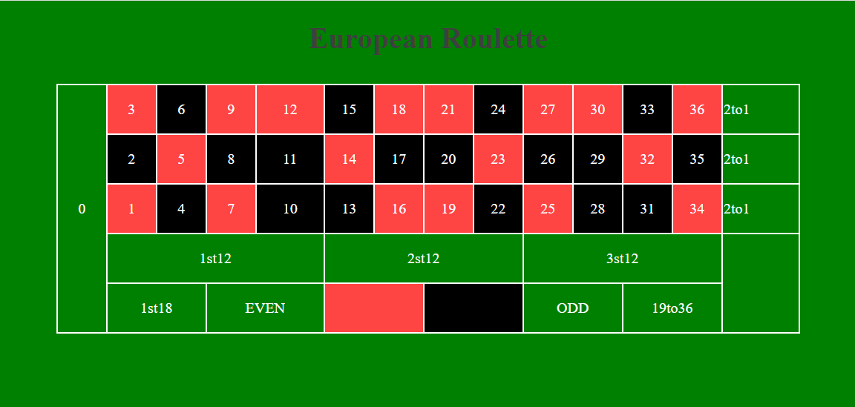

1. **Create Registration form using HTML, CSS?**

1. **In how many ways can a CSS be integrated as a web page?**

* There are three ways to integrate CSS on web page
* Inline: Inside the html tag using style tag
* Internal: Create style tag inside the header position
* External: Create page for CSS and link that page to html page.

1. **Create simple three pages using External CSS, Internal CSS, and Inline CSS?**

* Inline CSS: Inside the html tag using style tag

* Internal CSS: Create style tag inside the header position

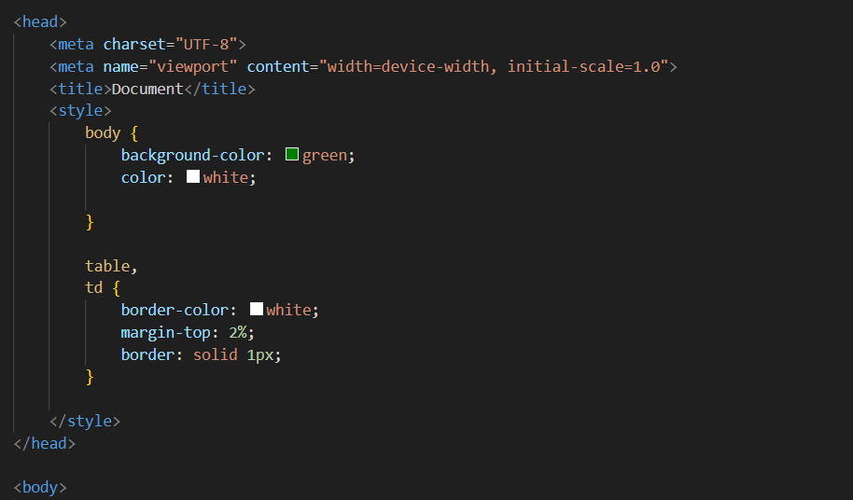

* External CSS: Create page for CSS and link that page to html page.

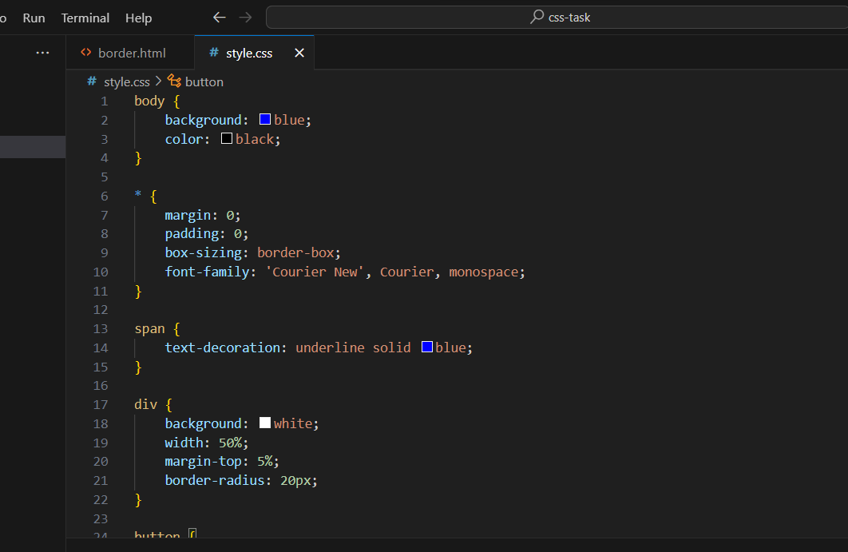

* Link give in html header position

1. **Create below page using HTML CSS?**

1. **Create link-pseudo classes using external CSS, to format links on the pages.**

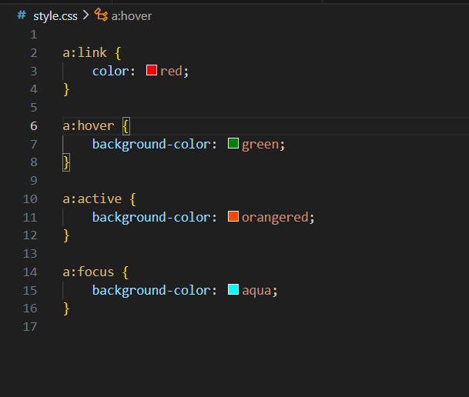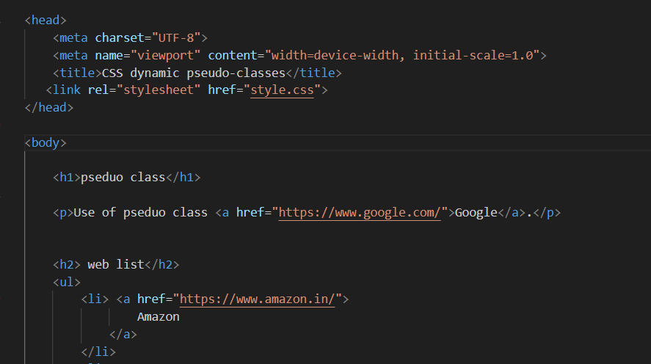

* **Output:**

1. . **Create a dynamic pseudo class using HTML, CSS**

* A pseudo-class is used to define a special state of an element.
* The single (:) colon is used for pseudo class.

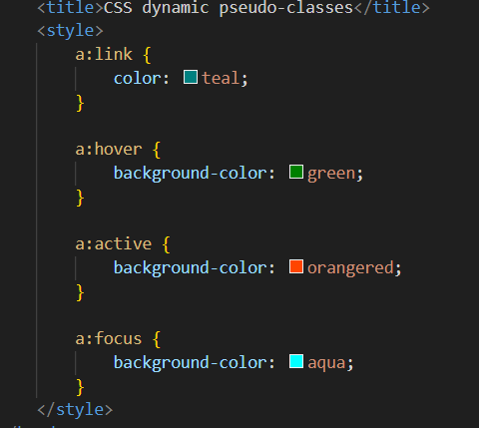

------------------------------------------------------------------END-------------------------------------------------------------